**VOS Deployment Automation Guide**

**Version Control**

|  |  |  |  |  |
| --- | --- | --- | --- | --- |
| **Version** | **Date** | **Author** | **Reviewer** | **Change Summary** |
| 0.1 | 05/12/2023 | Shraddha Dhumal | Vinod junghare | Initial Draft |
| 0.2 |  |  |  |  |
| 1.0 |  |  |  |  |

Table of Contents

**VOS Files in Gitlab** 3

**Gitlab User token creation** 3

**Adding Credentials in Jenkins** 5

**Nexus Upload Pipeline** 7

**Code Deployment Pipeline** 8

# **VOS Files in Gitlab**

Below tables provides information on Gitlab Repo & branch details used in different DEX pipelines.

* Gitlab Repo used here is - <http://devops01.connex.ro:9080/gitlab/autodeployment/3c.git>
* The Repo contains branch named “VOSDeployment” where code & files used for different pipelines has been kept.

|  |  |  |  |
| --- | --- | --- | --- |
| **Branch** | **Branch Purpose** | **File** | **File Purpose** |
| VOSDeployment | This branch contains files to be used in VOSDeployment for deployment of both UAT and PET Pipelines. | VOS_Deployment/ Environment.txt | File contains mapping of username to be used to login to server based on the environment. |
| VOSJenkins/VOSUploadToNexus | This file is referred in Nexus Upload Pipeline & contains logic to versioned code, config files & load to Nexus |
| VOSJenkins/VOSDeployment | This file is referred in UAT deployment pipeline & contains logic to deploy application code and database deployment. |

# **Gitlab User token creation**

* For Jenkins to communicate with GitLab, a user access token needs to be created. Gitlab does not allow simple user/password logins anymore.
* This token can be set to expired as per requirement with a default timeline of 1 year as expiry.
* Below process shows process of user creation in Gitlab
  + Login to Gitlab with authorized user.
  + Click on Blue icon & then on preferences tab.

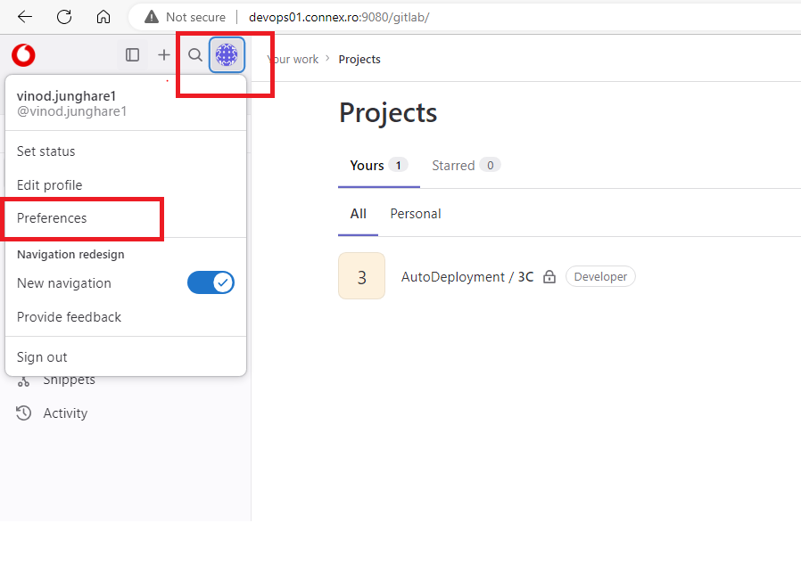

* Once into preference clink on Access token on the left panel

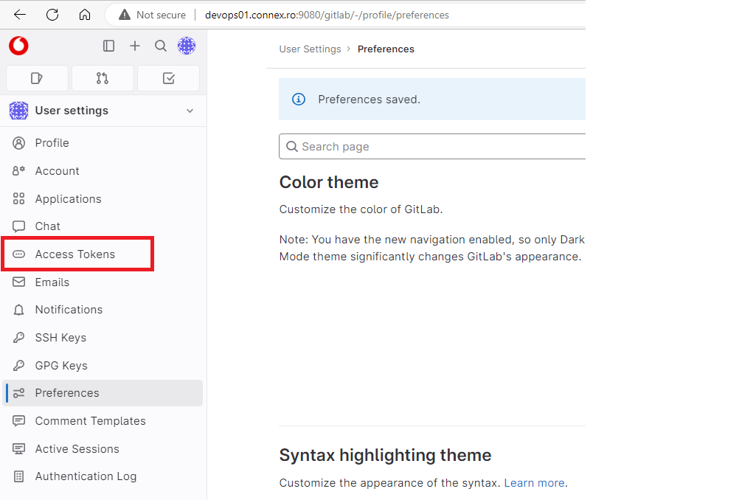

* On Personal access token screen, select all the access, provide the token name and click on generate token.
* The created token can be observed under personal access token.
* Please make sure to note and store it as once page is gone the token cannot be seen again, a new token must be created incase access token is missed or forgotten.

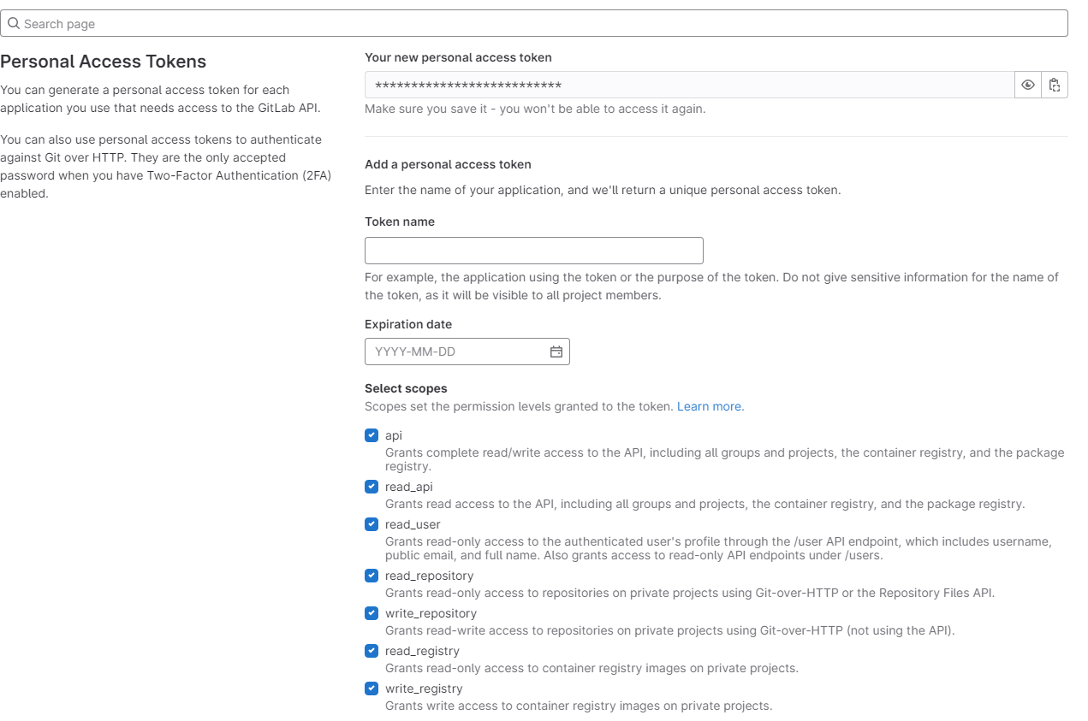

* The above created access token needs to be configured in Jenkins as credentials, which can then be used to communicate with Gitlab from Jenkins.

# **Adding Credentials in Jenkins**

* Process below to add credentials in Jenkins.
  + Login to Jenkins with authorized id, for adding credentials in Jenkins elevated access is required.
  + Click on Manage Jenkins

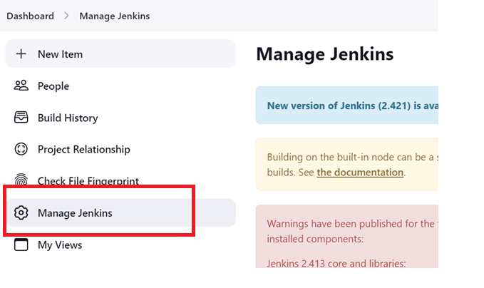

* Once in Managed Jenkins page, click on credentials

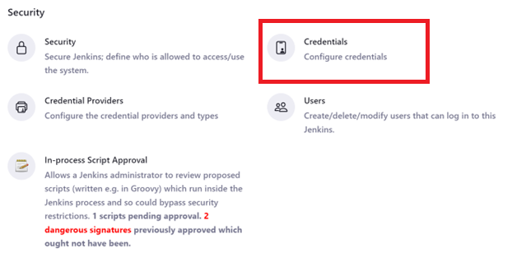

* Search for system and click on the global domain.

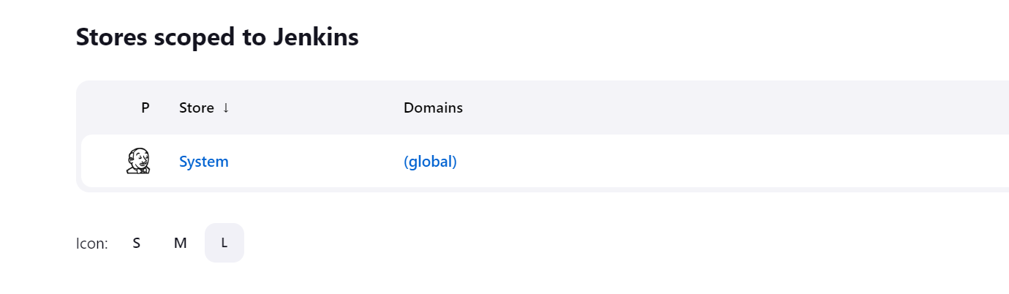

* On Global credentials page, you will be able to see “Add Credentials” option.

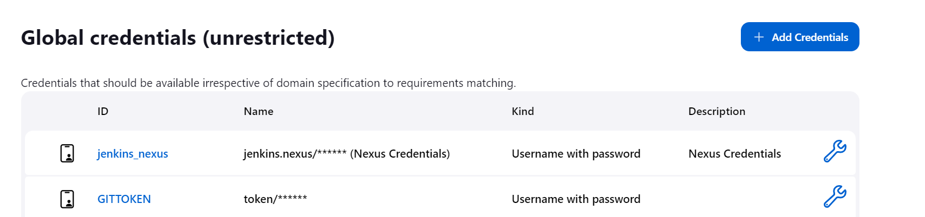

* On Credentials page, select option Username with Password, add your username in field & copy the access token to the password field & save the credentials.

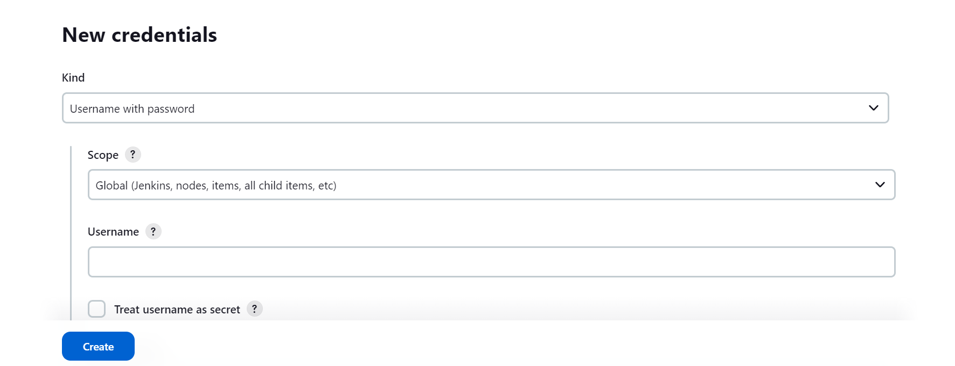

* Finally, the added credentials can be used into Pipeline as below.

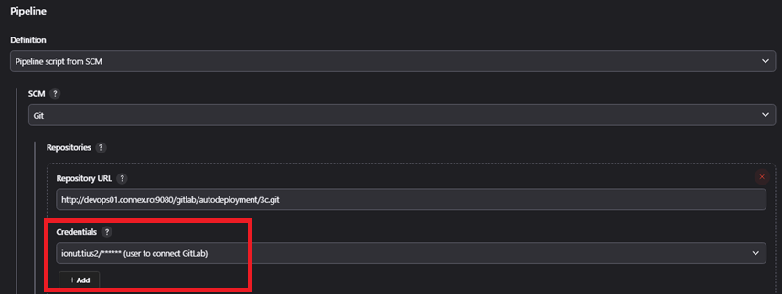

# **Nexus Upload Pipeline**

* This pipeline performs following tasks –
  + Copy release artifacts from DLV server to Jenkins temporary workspace.
  + For VOS dev team delivers the release directly onto DLV server.
  + Run this Workspace copy against specific set of rules defined in shell script to restructure, versionize & load it to nexus.
  + Clean & release Workspace memory post successful or unsuccessful action.
  + Nexus Upload is common pipeline that should be used to load code & config versionize files to Nexus and which is completely dependent on the filesinfo.csv which is being delivered as part artefacts delivery.
  + Deliverables agreed from VOS Dev Team as below.

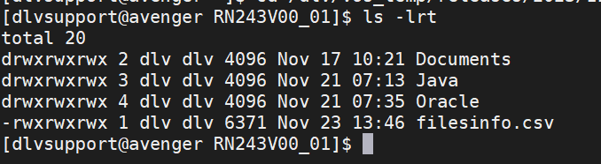

* + - Snapshot post versioning & loading into Nexus.

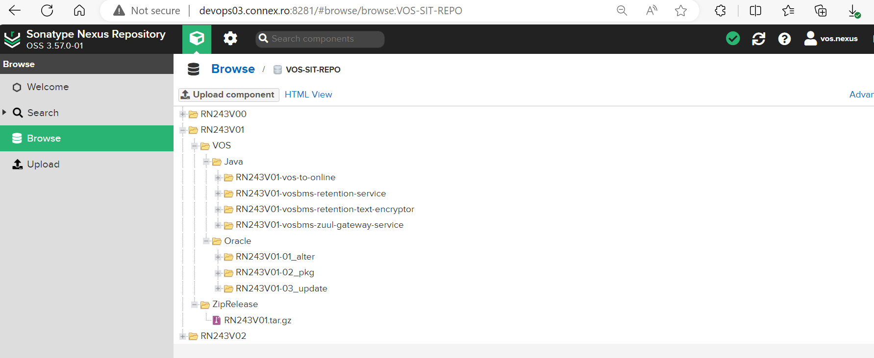

* + - The VOS_Nexus_Upload Pipeline takes inputs namely ***Release*** which needs to be Versioned & loaded to nexus.

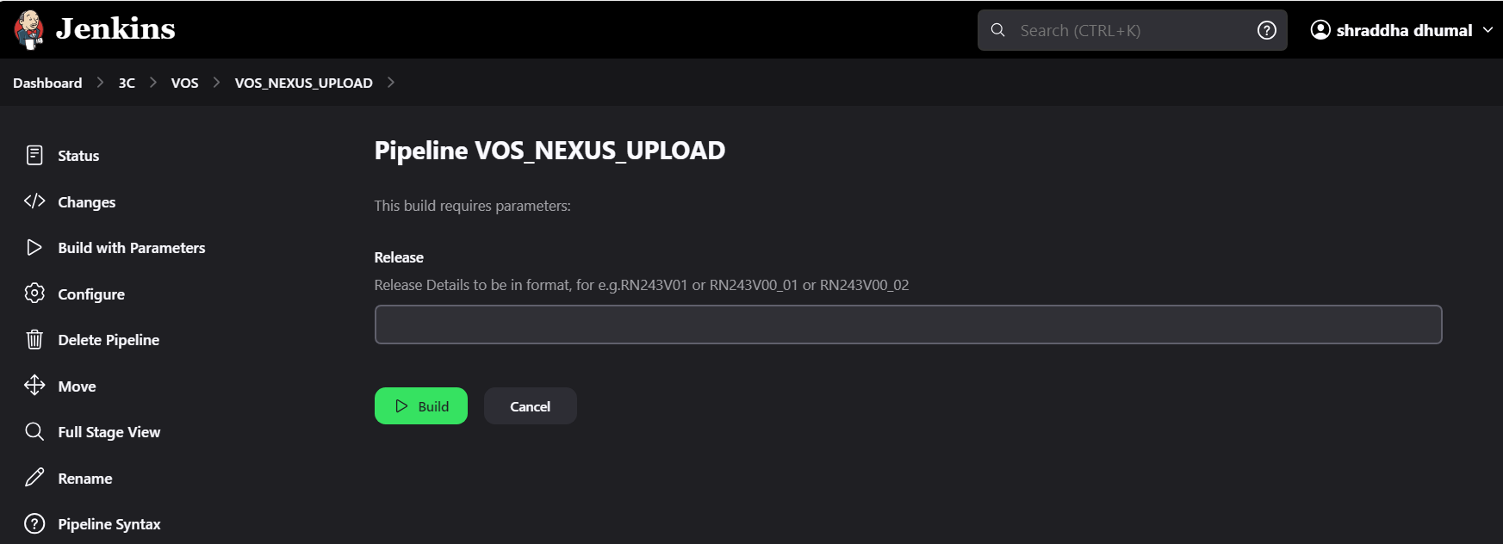

* + - Snapshot below showing different stages of VOS_Nexus_Upload pipeline post run.

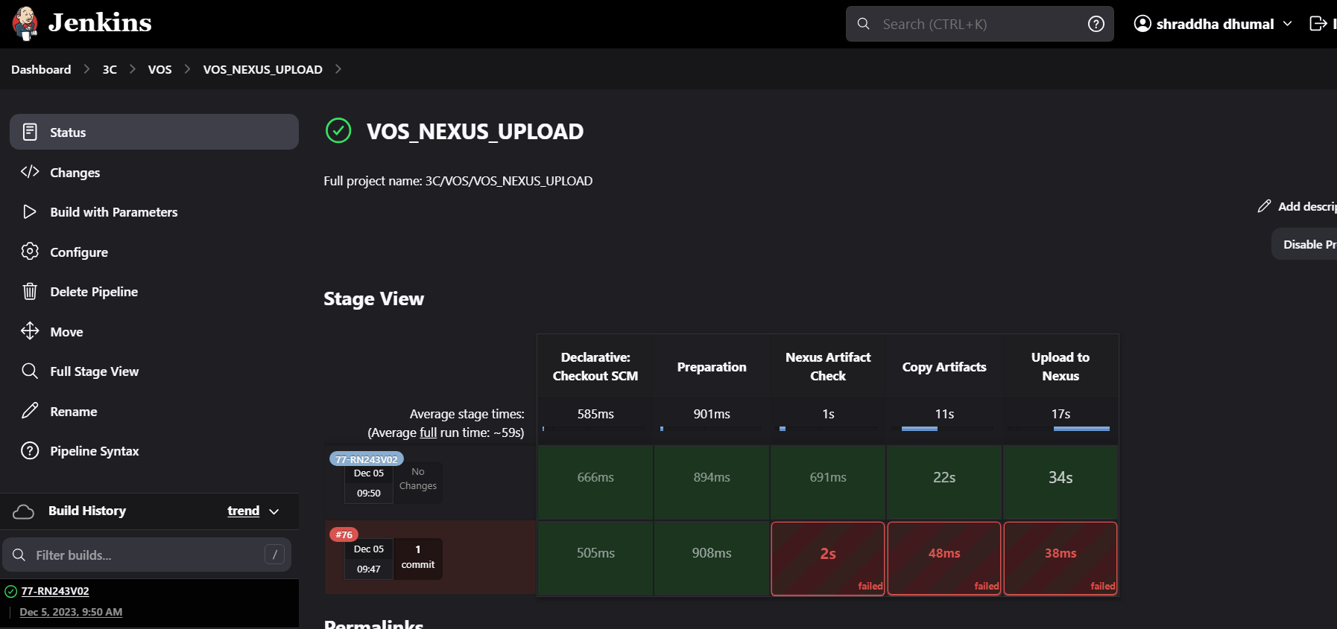

# **Code Deployment Pipeline**

* + This pipeline is used to deploy necessary files from given release
  + This pipeline needs to be used post VOS_Nexus_Upload Pipeline as this Pipeline pulls data from Nexus for deployment.
  + The pipeline can be used to deploy UAT as well PET Deployments.
  + Pipeline performs below task –
    - Download release artifact tar file for given Release & Sub Release.
    - Extract artifacts into folder with Release number in Jenkins Workspace.
    - Perform Deployment of respective application based on files available.
    - VOS_Deployment Pipelines takes 2 inputs parameters namely ReleaseSubRelease together & Environment on which deployments needs to be performed
    - Pipeline designed for both incremental and full release deployment. Where for full deployment input needs to be provided in comma(,) separated.
* Once given requirement inputs, Pipeline will perform below stages based on the files available for deployment.

